Calendar Month
# Source: AI Source: Provided by: [Data Path: Persons Table -> ID Column: 1, Name_En Column: Motasem Essam] -> From: [ChatGPT] on [7/17/2026]
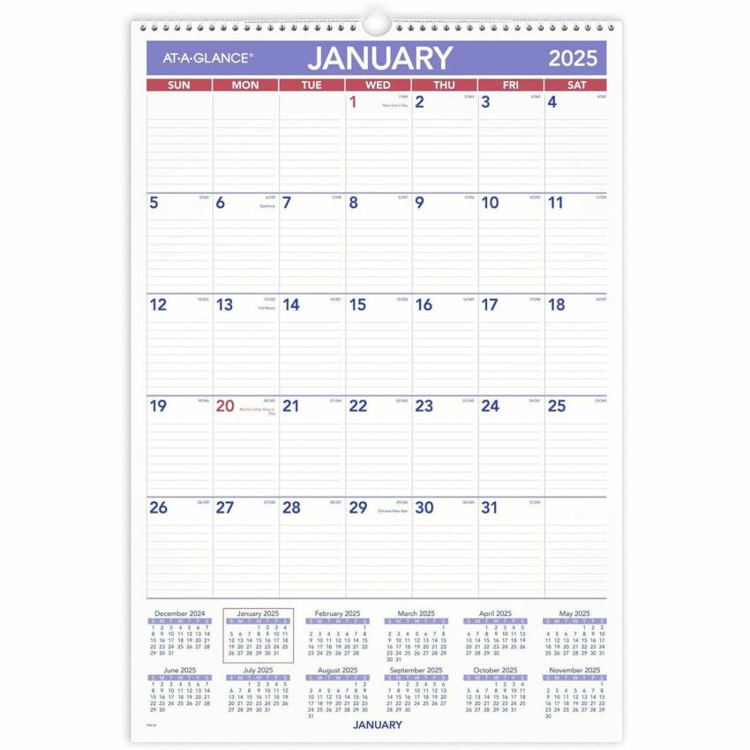
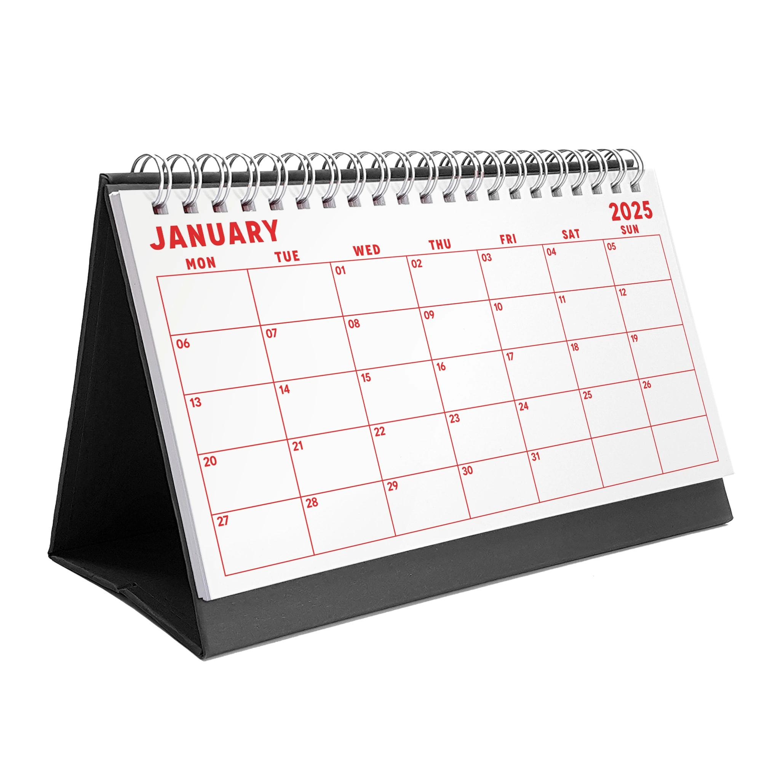


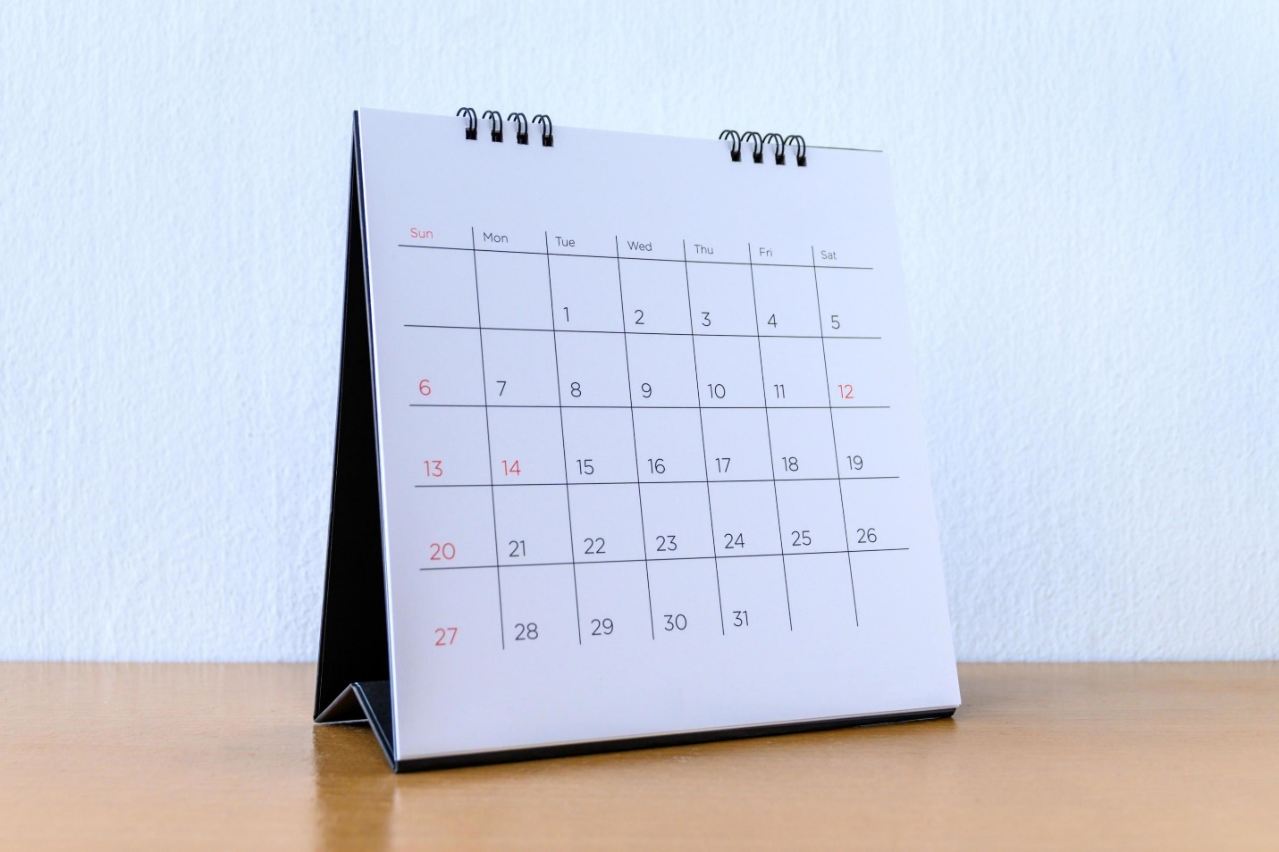
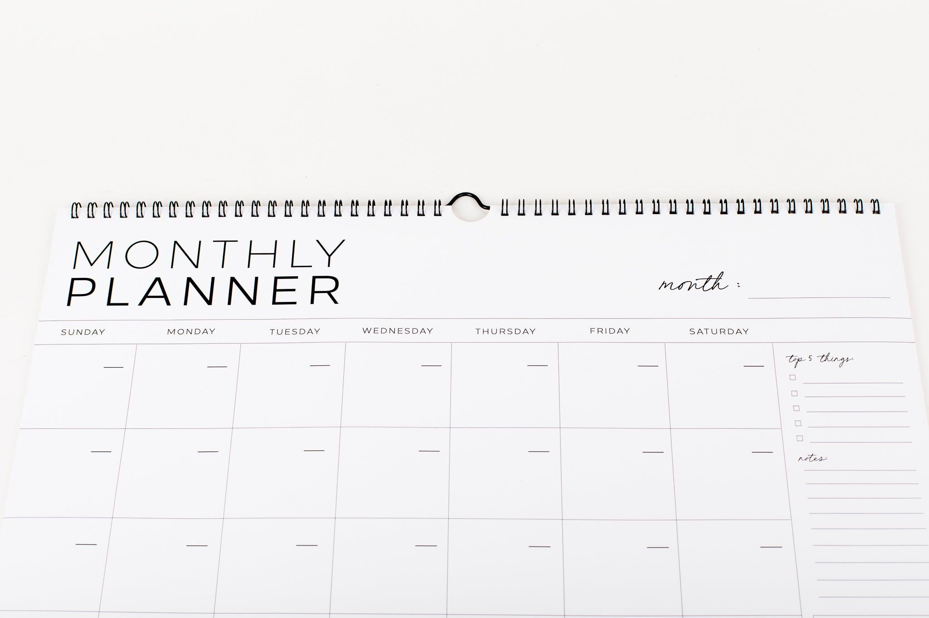
A Calendar Month is one of the twelve fixed divisions of a calendar year. Unlike a lunar month, which is based on the phases of the Moon, a calendar month has a predetermined number of days according to the calendar system being used.
In the Gregorian Calendar, calendar months contain 28, 29, 30, or 31 days and together make up one calendar year.

Definition
# Source: AI Source: Provided by: [Data Path: Persons Table -> ID Column: 1, Name_En Column: Motasem Essam] -> From: [ChatGPT] on [7/17/2026]
A Calendar Month is a fixed unit of time in a calendar that divides the year into twelve consecutive periods with predetermined lengths.

Purpose
# Source: AI Source: Provided by: [Data Path: Persons Table -> ID Column: 1, Name_En Column: Motasem Essam] -> From: [ChatGPT] on [7/17/2026]
Calendar months are used to:
- Organize the calendar year.
- Schedule events.
- Record dates.
- Plan business activities.
- Manage education.
- Track financial periods.
- Measure long-term time.

Number of Calendar Months
# Source: AI Source: Provided by: [Data Path: Persons Table -> ID Column: 1, Name_En Column: Motasem Essam] -> From: [ChatGPT] on [7/17/2026]
A standard calendar year contains:
- 12 calendar months

Calendar Months in the Gregorian Calendar
# Source: AI Source: Provided by: [Data Path: Persons Table -> ID Column: 1, Name_En Column: Motasem Essam] -> From: [ChatGPT] on [7/17/2026]
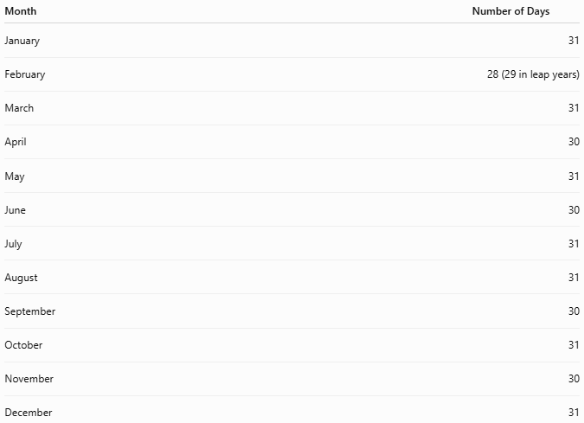
Month | Number of Days
January | 31
February | 28 (29 in leap years)
March | 31
April | 30
May | 31
June | 30
July | 31
August | 31
September | 30
October | 31
November | 30
December | 31

Length of a Calendar Month
# Source: AI Source: Provided by: [Data Path: Persons Table -> ID Column: 1, Name_En Column: Motasem Essam] -> From: [ChatGPT] on [7/17/2026]
A calendar month may contain:
- 28 days
- 29 days
- 30 days
- 31 days
Unlike lunar months, the length is fixed by the calendar, not by astronomical observations.

Position in the Year
# Source: AI Source: Provided by: [Data Path: Persons Table -> ID Column: 1, Name_En Column: Motasem Essam] -> From: [ChatGPT] on [7/17/2026]
Each calendar month occupies a fixed position.
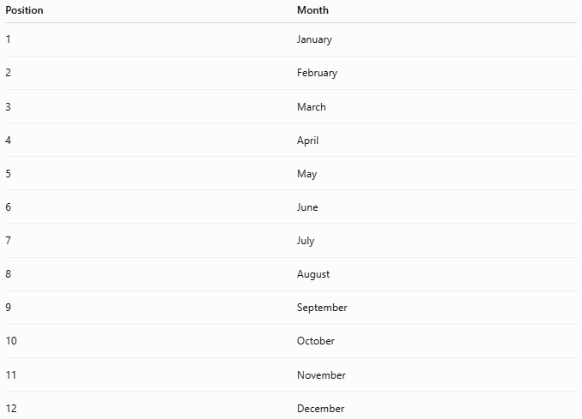
Position | Month
1 | January
2 | February
3 | March
4 | April
5 | May
6 | June
7 | July
8 | August
9 | September
10 | October
11 | November
12 | December

Relationship to Other Time Units
# Source: AI Source: Provided by: [Data Path: Persons Table -> ID Column: 1, Name_En Column: Motasem Essam] -> From: [ChatGPT] on [7/17/2026]
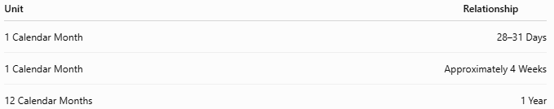
Unit | Relationship
1 Calendar Month | 28–31 Days
1 Calendar Month | Approximately 4 Weeks
12 Calendar Months | 1 Year

Applications
# Source: AI Source: Provided by: [Data Path: Persons Table -> ID Column: 1, Name_En Column: Motasem Essam] -> From: [ChatGPT] on [7/17/2026]
Calendar months are used in:
- Civil calendars
- Government records
- Education
- Banking
- Business reporting
- Payroll
- Medical appointments
- Legal documents
- Project planning

Examples
# Source: AI Source: Provided by: [Data Path: Persons Table -> ID Column: 1, Name_En Column: Motasem Essam] -> From: [ChatGPT] on [7/17/2026]
Examples of calendar dates include:
- 15 January 2026
- 30 April 2026
- 1 September 2026
- 25 December 2026
Each uses a calendar month rather than a lunar month.

Advantages
# Source: AI Source: Provided by: [Data Path: Persons Table -> ID Column: 1, Name_En Column: Motasem Essam] -> From: [ChatGPT] on [7/17/2026]
Calendar months:
- Provide a consistent structure for the year.
- Simplify scheduling and planning.
- Support international standards.
- Are easy to use in business and education.
- Remain fixed from year to year.

Limitations
# Source: AI Source: Provided by: [Data Path: Persons Table -> ID Column: 1, Name_En Column: Motasem Essam] -> From: [ChatGPT] on [7/17/2026]
Calendar months:
- Do not exactly match the Moon's phases.
- Have unequal lengths.
- May not correspond to natural astronomical cycles.

Comparison with Other Types of Months
# Source: AI Source: Provided by: [Data Path: Persons Table -> ID Column: 1, Name_En Column: Motasem Essam] -> From: [ChatGPT] on [7/17/2026]
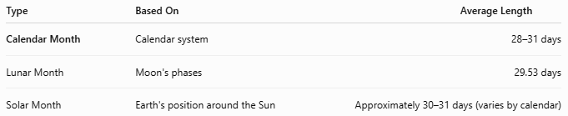
Type | Based On | Average Length
Calendar Month | Calendar system | 28–31 days
Lunar Month | Moon's phases | 29.53 days
Solar Month | Earth's position around the Sun | Approximately 30–31 days (varies by calendar)

Common Mistakes
# Source: AI Source: Provided by: [Data Path: Persons Table -> ID Column: 1, Name_En Column: Motasem Essam] -> From: [ChatGPT] on [7/17/2026]
- Confusing a calendar month with a lunar month.
- Assuming every calendar month has 30 days.
- Forgetting that February has 28 or 29 days.
- Assuming every month contains exactly 4 weeks (most months are slightly longer).

Interesting Facts
# Source: AI Source: Provided by: [Data Path: Persons Table -> ID Column: 1, Name_En Column: Motasem Essam] -> From: [ChatGPT] on [7/17/2026]
- The names of the Gregorian calendar months come primarily from:
  - Roman gods (e.g., January from Janus).
  - Roman emperors (e.g., July from Julius Caesar, August from Augustus).
  - Latin numbers (e.g., September, October, November, December, originally meaning the 7th, 8th, 9th, and 10th months in the early Roman calendar).

Key Points
# Source: AI Source: Provided by: [Data Path: Persons Table -> ID Column: 1, Name_En Column: Motasem Essam] -> From: [ChatGPT] on [7/17/2026]
- A Calendar Month is one of the 12 fixed divisions of a calendar year.
- Gregorian calendar months contain 28–31 days.
- Their lengths are determined by the calendar system, not by the Moon.
- Calendar months are widely used for:
  - Scheduling
  - Business
  - Education
  - Government
  - Everyday life

Conclusion
# Source: AI Source: Provided by: [Data Path: Persons Table -> ID Column: 1, Name_En Column: Motasem Essam] -> From: [ChatGPT] on [7/17/2026]
A Calendar Month is a fixed unit of time used to divide the year into twelve organized periods. In the Gregorian Calendar, each month has a predetermined length ranging from 28 to 31 days, providing a stable and practical framework for civil life, business, education, and record keeping. Unlike lunar months, calendar months are not tied directly to the Moon's phases, making them a standardized and internationally recognized component of modern timekeeping.

